Member 1: Tenia Xu Yuan (P1935334)

Member 2: Sebastian Pang (P1935631)

Game Design Document

Page

**1.0** Title

**1.1** Introduction

**2.0** Game Overview

**2.1** Console

**2.2** Concept

**2.3** Genre

**2.4** Target Audience

**2.5** Objective

**2.6** Game Structure

**2.7** Game Flow Summary

**3.0** Goals for CSS

**3.1** Safety Gear

**3.2** Gas Leak

**3.3** Fire Safety

**4.0** Gameplay

**4.1** Safety Gear

**4.2** Gas Leak

**4.3** Fire Safety

**5.0** Game Elements

**5.1** Location

**5.2** Story

**5.3** Map Art

**6.0** The Experience

**7.0** Assets – 2D/3D Models

**1.0** Title

Construction Site Safety (CSS)

**1.1 Introduction**

This document specifies a design for the gameplay of a game with the title “Construction Site Safety”. This document is intended to be read by programmers, artists and producers involved in the design, implementation and testing of “Construction Site Safety”.

**2.0** Game Overview

**2.1 Console**

Oculus Quest



**2.2 Concept**

CSS is a VR game to be played on Oculus to allow players to learn more about safety procedures on a construction site.

**2.3 Genre**

Simulation – Construction and Management Simulation

**2.4 Target Audience**

Players who want to learn more about safety procedures on a construction site.

**2.5 Objective**

To educate players on how to protect themselves and others on a construction site.

**2.6 Game Structure**

The level of difficulty is designed based on the player’s efforted needed when executing the safety procedures.

There will be a total of 3 different level:

Level 1: Safety Gear

Level 2: Gas Leak

Level 3: Fire Safety

Players can choose the level of difficulty to test out the various safety procedures.

Players can press the “Restart” button if they want to restart the game.

Players can press the “Quit” button if they want to quit the game application.

**2.7 Game Flow Summary**

Since this is a simulation game, the game is designed for players to move around the map freely, hence there is no rules that will limit the players’ movement.

The spawn location of the player does not change every round, hence the player will be required to navigate around the map to locate the safety procedures. Players can simply read the instructions shown on the board to better understand and learn about safety procedures on a construction site.

**3.0** Goals for CSS

**3.1 Safety Gear**

Allow players to learn to put on safety gears before starting work on a construction site. Safety gears act as a protection to reduce exposure to hazards and lessen likelihood of injury.

**3.2 Gas Leak**

Allow players to learn what to do in an event of a gas leak. This prevents explosion and keeps workers safe from possible harmful gas.

**3.3 Fire Safety**

Allow players to learn what to do in an event of a fire outbreak. This is to ensure that players are equipped with the knowledge to know how to put out a fire in order to reduce damages and save lives.

**4.0** Gameplay

**4.1 Safety Gear**

Steps to take:

1. Grab the helmet.

2. Bring helmet to head area.

3. Helmet snapped to head. (Task completed)

**4.2 Gas Leak**

Steps to take:

1. Grab the mobile phone/walkie talkie.

2. “Communicate” with higher ups.

3. Gas leakage will be fixed. (Task completed)

**4.3 Fire Safety**

Steps to take:

1. Grab the fire extinguisher.

2. Pull out pin form fire extinguisher.

3. Bring fire extinguisher close to fire.

4. Gas comes out from fire extinguisher and fire is taken out. (Task completed)

**5.0** Game Elements

**5.1 Location**

The game is designed such that the player will be spawned on a **construction site**. The spawn location of the player does not change, hence the player will be required to navigate around the map to locate the safety procedures.

**5.2 Story**

The game will be set in a present-day world.

Player’s identity would be a construction site worker who aims to learn more about safety on the construction site to avoid any possible injuries or fatalities to protect himself/herself and others.

**5.3 Map Art**

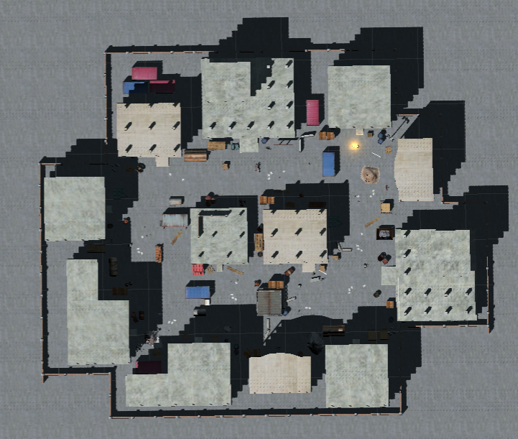

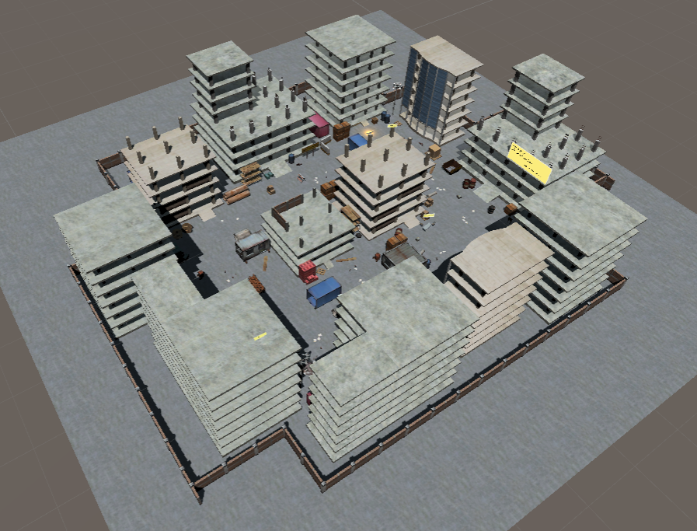

**-insert more images-**

Usage of tall buildings, construction vehicles and other necessary objects to make the construction site look more realistic.

**6.0** The Experience

To sum it up, Construction Site Safety (CSS)

**7.0** Assets – 2D/3D Models

-ss models I created/models given by cher-